Customer Service
Land, Planning and Building Services Shopfront
GPO Box 158
CANBERRA CITY ACT 2602

Dear Mr Ponton

DA202241265 – 17 to 23 Townsend St - Section: 30 Block: 1

Thank you for the opportunity to comment on this proposal. The Woden Valley Community Council (WVCC) supports the renewal of the Phillip Trades precinct and appreciates that there are people needing homes.

However, we advocate for densification to be done in the context of an overall plan and at this stage it is not clear what the future of the Phillip Trades precinct is:
- What will happen to the trades businesses with much of the area being zoned for housing.
- Will the trades businesses and apartments co-exist and if so, what is the plan for this to happen?
- The precinct is advertised as the new Braddon, how will this happen with 3m pavements that are too narrow for al fresco dining?

The proposed development is a 22m, 5-storey mixed use build to rent development with 43 units and 3 ground floor commercial tenancies on 1,239m2. The site also features a service/access driveway to the east of the site, two levels of basement carparking to accommodate 65 car parking spaces and resident storage cages.

Density
The height is unnecessarily high for 5 storeys.
Setbacks
The 3m pavements need to widened to 6m (to be the same as Lonsdale St in Braddon) if we are going to achieve the goal of an active streets for a day and night entertainment economy.
To create activity, we need wider pavements for al fresco dining and pedestrian/cycle movements.
Cycle path
Where is the cycle path through the centre of the Phillip Trades precinct?
Street trees and landscaping
I appreciate Colbee Court has a park nearby, however each site needs to contribute to the tree canopy to reduce urban heat islands and keep the precinct cool. The development needs to be smaller to provide space to contribute to the tree canopy and public realm.
We need more than a pot planter at the corner of the building and wider pavements to allow room for deep-rooted trees
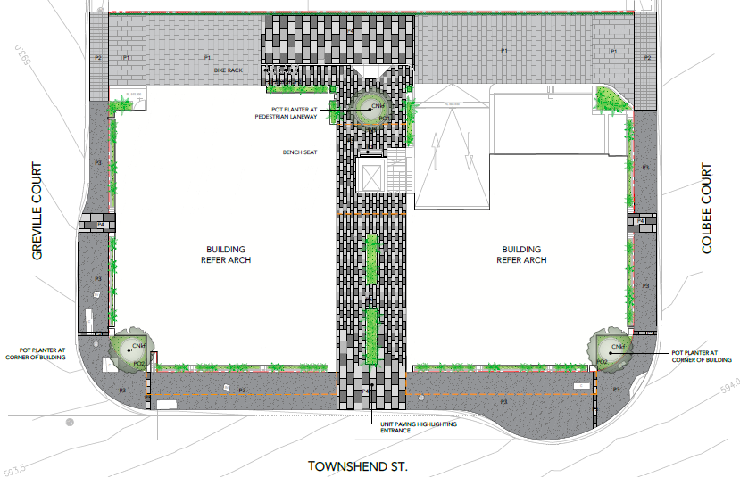
Setbacks
Pavements 3m
Attic
Commercial tenants
As the Phillip Trades precinct is converted to housing, what will happen to the commercial trades businesses?
Where will the Trades precinct be in 20 years, will there be any trades left?

EV charging

Traffic congestion and carparking
There are over 30 high density towers in Woden and traffic is becoming congested and parking difficult. To facilitate liveable, walkable streets to establish, traffic should be directed out of the Town Centre to Callam St and not into internal roads, for example the proposed connection between Bradley St and Bowes St.
The basement carparking is appreciated. The CIT will not have any carparks for students and it is understood that ScentreGroup will provide the required carparking for the new facility. We would like confirmation that arrangements for student parking in the Westfield carparks has been agreed.
Public realm
Woden is known for its concrete so this development could bring more greenery and deep rooted trees to the area to soften the space. The interface of the ground floor to the outside public realm is particularly important to create activity. Measures to make the outside area more attractive would be appreciated.

Overshadowing and wind
The development needs to be rounded and slender to minimise the down draft and wind at ground level, and the large, slow moving shadow which will be cast over the area.

Consultation

This process was not adequate to let the community know about the development. It was held in December when everyone was busy, the on-line session was cancelled and there awas no a. The future of this precinct is important to locals and

Yours sincerely
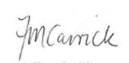
Fiona Carrick
President, Woden Valley Community Council
27 February 2023

Attachment A
Bonner House east, 9 Bradley St

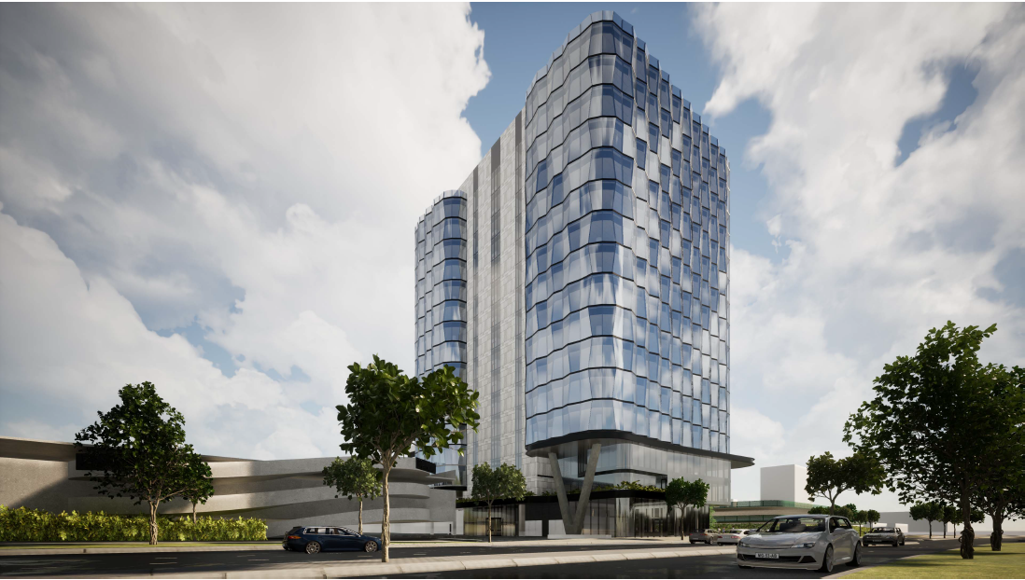

Some more green areas would be good to soften the significant amount of concrete in Woden

